Building out the Draft Stats for Coaches

Building out the Draft Stats for Coaches 1
Preface 1
High Level Overview 1
Detailed Steps
(with screenshots) 2
1) Aggregate all end of season stats 3
1a) Mobile App Option 3
1b) Web Gui Option 4
2) Update “Staging” sheet: 4
3) Copy Template to New File: 7
4) Copy Last 2 Seasons of Stats: 7
5) Export Registration and Challenge .csv files 8
6) Update Player Info (DoB, Draft, Challenge) 11
7) Sanity Checks 14

Preface
There are several ways this has historically been done in the short time we’ve been providing coaches with draft stats. The initial manual process can be quite time consuming and prone to errors, misses, or mistakes. Below we outline a process that has been 95% automated to save time and reduce errors. If you would prefer to use the manual process, you can view the “How Tos” here Manual Process

Goal: No matter which process you utilize the goal thus far has been
1) Maintain historical sheet of all stats from all seasons
2) Build a draft stats sheet for each upcoming season, usually consisting of the prior two seasons worth of stats (2 seasons as it is common for many players to not play one of fall or spring).

Below is a very high level overview, as well as a detailed step-by-step of how to complete both of the above

High Level Overview
Pro Tip: Gamechanger sucks and doesn’t have a standard format for all stats.csv files, so one coach’s .csv file may have stats in diff columns than another coach's .csv file. You are more than welcome to go through manually and figure it all out, or you can use the automated approach we’ve built below.

- Aggregate all end of season stats from coaches (collect all .csv files from coaches).
- Update “Staging” sheet: Copy/Paste the contents of those .csv files into the “Staging” sheet of ALL_Seasons_Stats as this is our single source of truth (SSoT) document for all historical stats.
Note: Copy/Paste 1 at a time, deleting prior team stats from Staging sheet
before adding next team stats)
- ALL_Seasons_Statshas 3 key sheets
  - Staging = temporary data sheet where you copy and paste the coaches .csv data one team at a time
  - Raw_Stats = ALL stats recorded, properly aligned in a standard format
  - Draft_Stats = A subset of “Raw Data” stats that should be a more usable set of stats for the draft, and will eventually be copied and pasted into a separate file and act as the foundation of our final draft sheet for registered players.

So in short, the workflow is
  - Individual coaches .csv files → ALL_Seasons_Stats “Staging” sheet → automatically builds Raw Data → Automatically builds Draft Stats

- Copy Template to New File: Template-Seasonal_Stats-Automated_Fullyand “Make a Copy” , saving the new file as “Spring 2026 Draft Stats” (obviously replace the season/year as needed) and saving in its corresponding folder (In this case it would be Spring26)
- Copy Last 2 Seasons of Stats: Copy the last 2 stats from the ALL_Seasons_Stats“Draft Stats” sheet (just use a simple filter), and paste into the new “Spring 2026 Draft Stats” “Draft_Stats” sheet you just saved/copied
- Download Registration and Challenge reports (custom reports) from Sports Connect, and paste this into the same new file “Spring 2026 Draft Stats”, “Registrations” and Challenge Tab respectively.
- Update Player Info: - Gamechanger → Update Draft Stats

Detailed Steps
(with screenshots)
This guide explains the process to aggregate and append all GC Stats to the single historical file we keep for all stats from prior seasons - ALL_Seasons_Stats. We keep this updated each season, and then this file becomes the foundation for the file we build for the draft stats (at least a subset of this file - as of Spring 2025 we’ve been taking just the past two seasons of data from the ALL_Seasons_Stats and using that as the foundation for the upcoming draft stats). So in short the workflow consists of (1) us aggregating all coaches stats that they send us, (2) appending the existing file (3) taking a subset (last 2 seasons) of that data to create a new file “Spring 2026 Draft Stats” where we will (4) update that file only for kids who have registered. This document will cover steps 1 and 2 just mentioned.
This historically has been a manual process where we have to (1) edit the received stats (combing through over 100 columns of data to delete certain columns and keep only stats of interest) (2) ensure stats from all coaches are aligned to the same columns, (3) then create a new file with just the prior two seasons of data and manually track new registrations (or removed registrations) and only update players who have registered.
As of Fall’25 and Spring ‘26 we are attempting to automate all of that process which will be outlined below.

Aggregate all end of season stats
from coaches (collect all .csv files from coaches).
- After the season ends, collect the .csv stats files from each coach.
- Coaches can collect this data via GC mobile app or GC web page, and send via text or email.

1a) Mobile App Option
- Go to your team
- Stats
- Export Stats
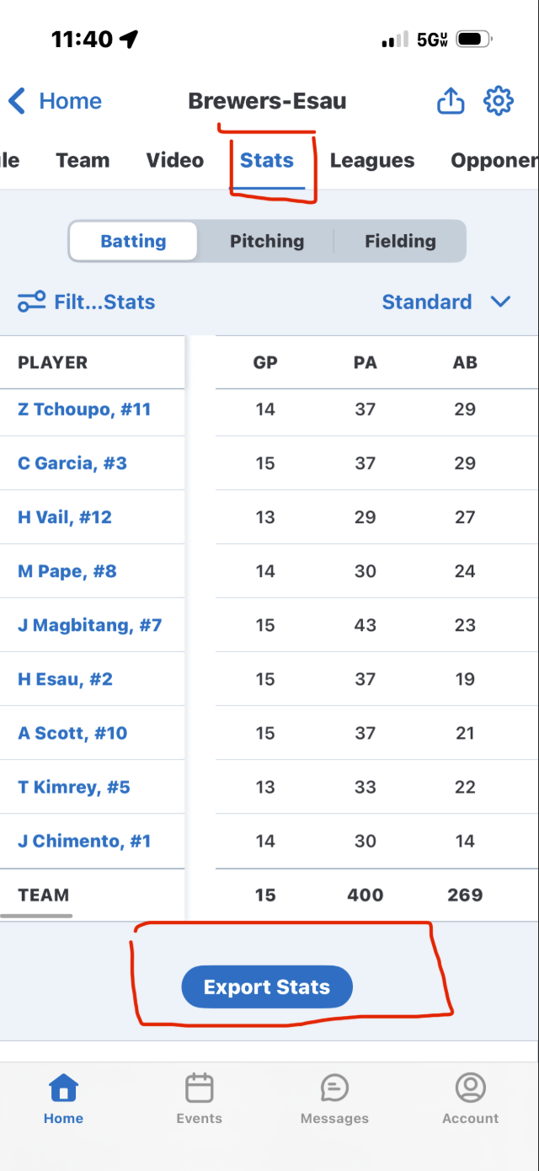

1b) Web Gui Option
- Go to your team
- Stats
- Export Stats
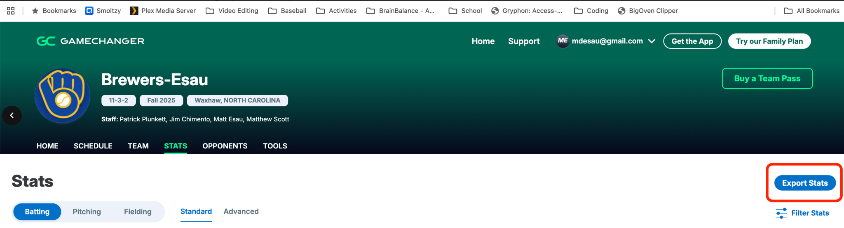

Update “Staging” sheet:
Copy/Paste the contents of those .csv files into the “Staging” sheet of ALL_Seasons_Stats as this is our single source of truth (SSoT) document for all historical stats.
Note: Copy/Paste 1 at a time, deleting prior team stats from Staging sheet
before adding next team stats)

Just make sure once pasted, the cell values b/t ALL_Seasons_Stats and the original .csv file match (example below, First player number should be in the same cell - in this case A3.
Select GC Automation → Import and Align Staging Data
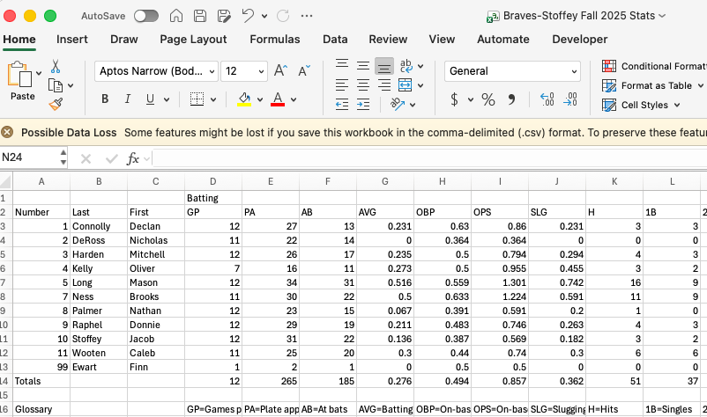
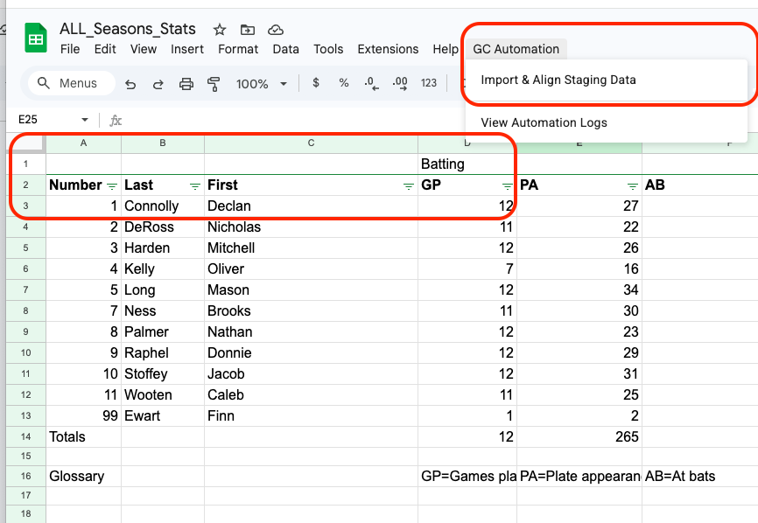

This should result in the “Raw_Stats” sheet being updated automatically, all of the stats properly aligned, and the recent entries highlighted in yellow so you can easily identify what was appended to the end of the sheet. Remember GC doesn’t make it easy on you b/c these .csv files are not all the same, so that is why you cannot just copy and paste this from .csv right into “Raw_Stats” b/c the stats won’t all align under the same category / column (ERA may end up under WHIP or Ks in some instances).

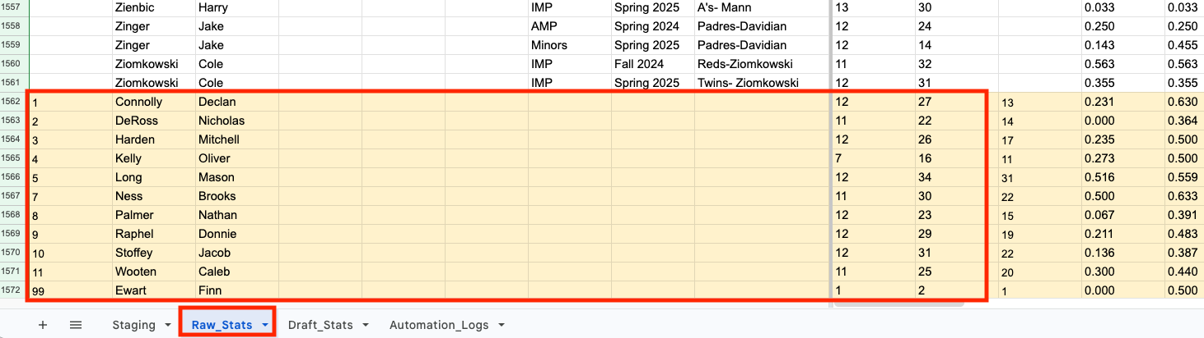

You will receive an Alert with some information on what was updated. You will often see the “Missing” value be non-zero… again this is because Gamechanger doesn’t export all of the stats.csv files in the same manner. Usually though, those stats missing are irrelevant stats like # of innings played at a position (other than catcher or pitcher). Gamechanger has not root-caused this yet.

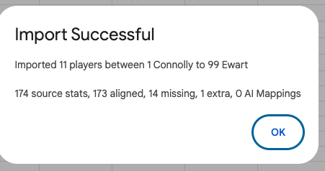
- Imported 11 players (number of players from the .csv file
- 174 source stats = # of stats / columns from the .csv file
- 173 aligned of those stats aligned properly with existing columns
- 1 extra stat appeared in the .csv file that didn’t exist in Raw_Stats
- 14 stats missing (again usually positions played)
- 0 AI mappings = I built in AI capabilities to help align stats b/c GC also doesn’t title every column the same (ex Batting Average vs Avg in diff .csvs) so I built a script to leverage AI to properly align these.

Usually unnecessary, but if it makes you feel better to know what was missing, or extra I built in an Automation Log tab, that will provide you detailed information of what was imported

Copy Template to New File:
Template-Seasonal_Stats-Automated_Fullyand “Make a Copy” , saving the new file as “Spring 2026 Draft Stats” (obviously replace the season/year as needed) and saving in its corresponding folder (In this case it would be Spring26) YOU SHOULD NOT UPDATE OR ALTER this template at any point
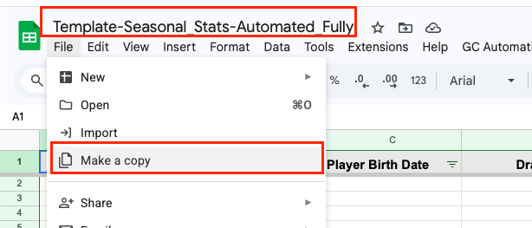

YOU ARE ONLY UPDATING NEWLY SAVED/COPIED file

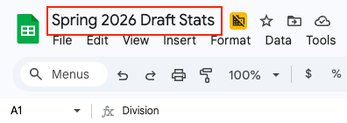

Copy Last 2 Seasons of Stats:
from the ALL_Seasons_Stats“Draft Stats” sheet (just use a simple filter), and paste into the new “Spring 2026 Draft Stats” “Draft_Stats” sheet you just saved/copied

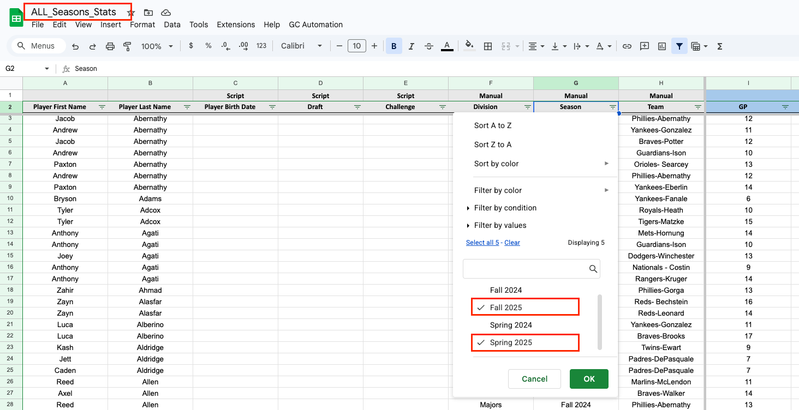
^^^^ All Season Stats File Above ^^^^
+++++
Newly Saved “Spring 2026” file Below
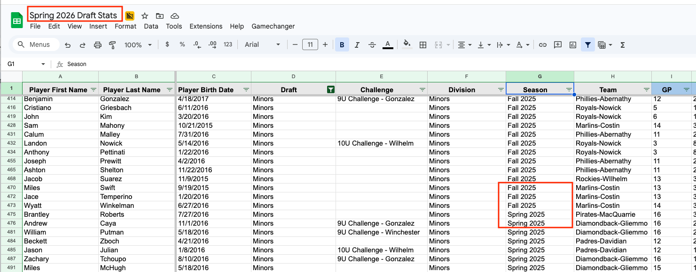

Export Registration and Challenge .csv files
(custom reports) from Sports Connect, and paste this into the same new file “Spring 2026 Draft Stats”, “Registrations” and Challenge Tab respectively.
Note: You will likely have to select these reports → Save As → and re-title them for the new season you’re working on. Then go in and modify the program or year (depending on how the reports categorize it for that year. Example after you Save As, you will likely need to go in and change Program from “Spring 2026 Rec” to “Fall 2026 Rec”. Should be pretty straightforward.
For Details you can see How To: Export Sports Connect Reports

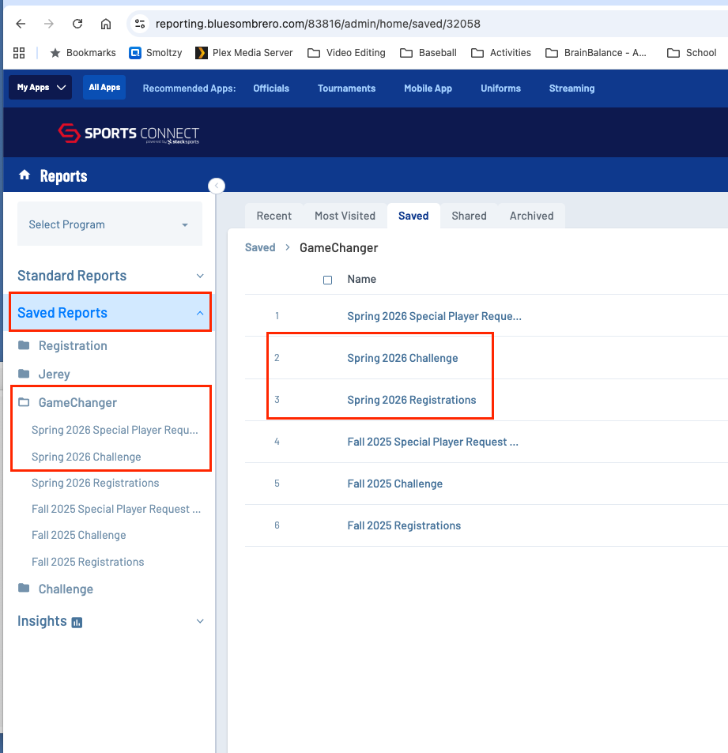

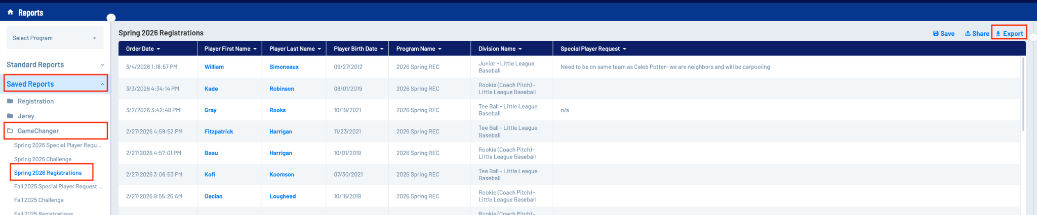

It is easiest if you copy just the data and not the header row (so no need to copy/paste Row-1)

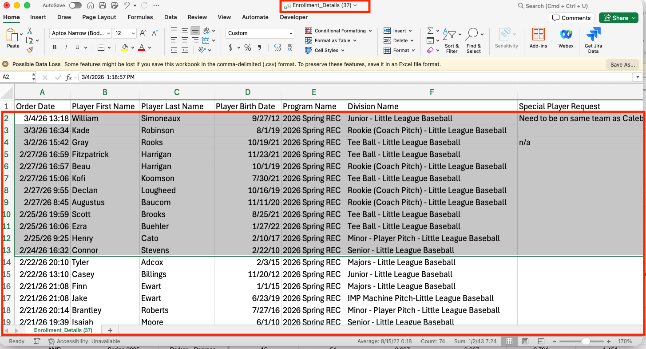

Paste the user data from above (starting from row 2) and paste it below the header row(s) of the
Spring 2026 Draft Stats file – Registrations tab.

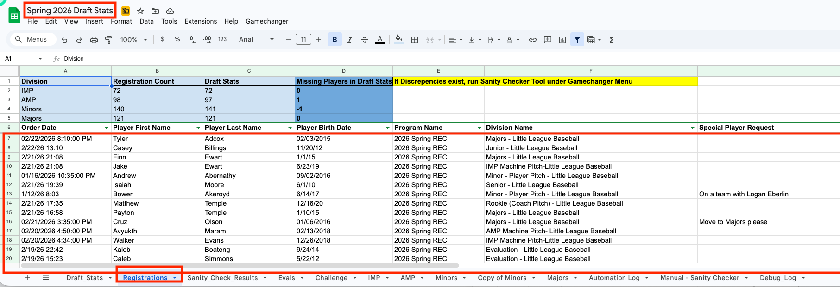

!!!! Repeat the above steps for the Challenge Report in sports connect and paste that data in the Challenge tab in the google sheet !!!!

Update Player Info (DoB, Draft, Challenge)
Update player info via the custom menu Gamechanger → Update Draft Stats
Once the data is pasted, select the menu Gamechanger → Update Draft Stats
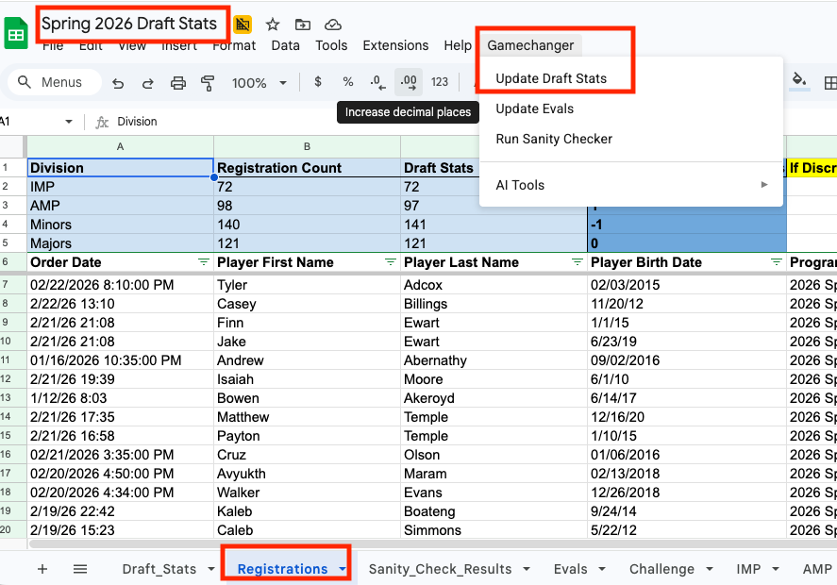
What is this doing?? This is taking all the names in Registrations sheet, and doing a search in Draft Stats. If it has a match, it will update the player information (see the chart below) for the player in the Draft_Stats sheet.

+================================================================+
| DATA MAPPING REFERENCE |
+-------------------+------------------------+--------------------+
| SOURCE SHEET | SOURCE COLUMN | DESTINATION |
| | | (Draft_Stats) |
+-------------------+------------------------+--------------------+
| Registrations | Player Birth Date | Player Birth Date |
| Registrations | Division Name | Draft |
| Registrations | Special Player Request | Special Player |
| | | Requests |
| Challenge | Team Name | Challenge |
+-------------------+------------------------+--------------------+

Pro Tip Note: You only need to paste the Challenge report data from Sports Connect into the google sheet 1x b/c once challenge teams are set, they are static. However, you will need to do an update on Registrations and repeat those steps all the way up until the registration closes.

We need this to be updated b/c it identifies the players we have stats for who are registered and who are not registered. You will see below that the players in red have no Birthdate or Draft value in the respective columns. The players in green do. You then know that those are the players that have registered (green) and those that have not (red). This is important because you don’t want to provide a final Draft list of stats for players who are not registered.

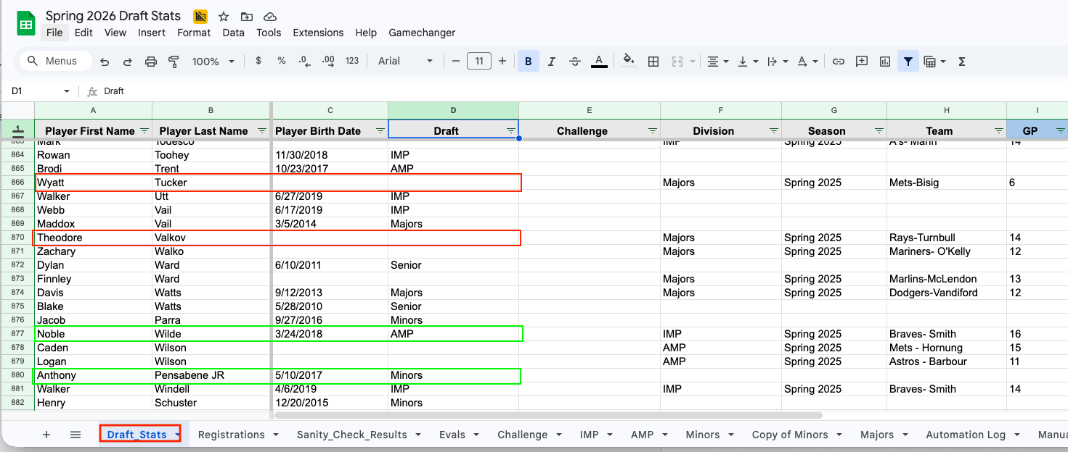
Pro Tip Note: Quite often parents will request a coach, or not to have a coach. To avoid embarrassing an individual for being “not requested”, or any other negative comments about volunteer coaches, we scrub the Special Player Requests, to remove any negative comments. You only have to do this once - Right before you get ready to provide the draft stats to the coaches. The commissioner should be aware of all comments however so that he can handle any “Negative Requests” or comments. To do this you can also download the “Special Player Requests” Report saved in the Gamechanger folder on Sports Connect:
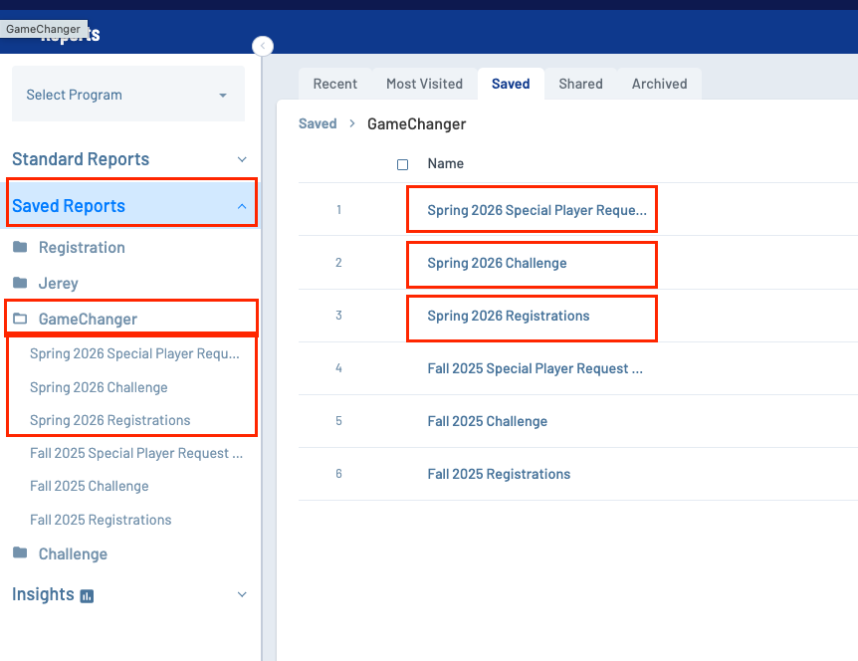

You will receive a message after you choose Gamechanger → Update Draft Stats that informs you of what was updated, and you can also view the “Automation log” tab for details.
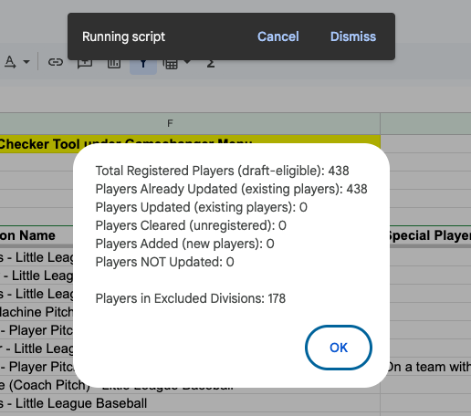
Total Registered = total number of players registered across all divisions and ages
Players Already Updated (existing Players) = number of players who were updated from previous iterations of you running the update. They existed in Draft Stats and had their DoB, Draft, and Challenge status updated
Players Updated: Players we have stats for, but are newly registered and thus “Updated”
Players Cleared: Players who were unregistered that were previously registered (rare)
Players Added = New players to the league, we had no stats for, and thus we had to add their name along with update DoB, Challenge, and Draft status
Players Not Updated: generally 0, if this happens, there is an issue (usually a name mismatch of some sort)
Players in Excluded Divisions = number of players in teeball, rookie, Juniors or Seniors. (we’re only looking for IMP -> Majors Divisions).

As Draft_Stats is being updated via the above process, it will automatically populate your IMP, AMP, Minors, and Majors tabs with their respective draft lists. (via =QUERY function)

We generally have over 500 Registrations that you previously had to manually comb through and update the draft stats. It is A LOT to keep up with. So i’ve built in a few Sanity Checks along the way.

Sanity Checks
  - Registrations Sheet: Has each Division and the number of kids registered in that division from the registration sheet and the number of kids that have the corresponding “Draft” column value updated (remember this happens when DoB, Draft, and Challenge is updated from the Gamechanger → Update Draft Stats menu. The values of Registration Count ←→ Draft Stats should match
  - Each Division tab has the same counter / tracker
  - If either of them are not matching, you can run 2 different sanity checkers
    - Manual Sanity Checker: instructions on the tab itself)
    - Automated Sanity Checker: Gamechanger → Run Sanity Checker

This should complete your Draft_Stats updation from the kids who are registered in each division.

